William Anthony Monague – Beausoleil First Nation Ojibwa Artist

AN ARTISTIC NARRATION:

As a young boy William grew up on an isolated island and home of the Beausoleil First Nation People. He could often be found spending his time doodling Indian princesses and discovered inspiration in the traditional teachings of Mother Earth, Spirit World and beauty of the nature and Georgian Bay shores that surrounded him. With no access to formal education or training in the arts William became a self-taught artist on a lifelong journey. With the encouragement of his sisters, mother and guidance of school teachers, art became his ambition. Equipped with the encouragement of family members and peers he left his Beausoleil First Nation community becoming a well- known Ojibwa Artist. During workshops and events William often shares the knowledge that learning is a lifelong journey.

After spending months creating an extensive amount of paintings, carvings and quillwork William Monague left his small community on Christian Island to sell his work. Throughout the 70’s and 80’s the self-taught artist travelled the Pow Wow trail to Mexico selling numerous paintings and carvings. For months he travelled and sold extensively while living out of his van. Curators from Washington Museum of Fine Art, The Turtle Gallery of New York and the Royal Ontario Museum among many others frequently acquired his traditional works of art while on the trail. Stores and Friendship Centres in Canada and the United States purchased his arts and crafts while on the Pow Wow trail. With monies earned from the Pow Wow trail he returned to Canada to purchase a home in Mission British Columbia where Monague Native Crafts Ltd. was established. The business bestowed with his name is now one of Canada's leading global producers and suppliers of native products.

Supporting worthwhile causes through donations of his art and time is important to him. He has never forgotten those who supported and recognized his talent, this allows him to remain dedicated to his work while inspiring and helping others. Creations often depict the celebration of women’s strength and are donated yearly in support of the fight to end violence against women. Recent completion of “Pine Tree” and “ButterFly Woman” marks the 20th anniversary of the Human Rights Office at Queen’s University. “Mystical Village” created in 1994 shortly after leaving Mission, B.C. to return to Christian Island chosen for the 2014 Edition Transcendence for the B.C. Multifaith Calendar was also nominated for a Canada Council for the Arts award for the unique method utilized to create the northern lights. Amidst the paintings and carvings the artist continues his artistic endeavour with the development of fictional characters for the story “Snowy and the Otter” and when finished will offer young and old, a fun and memorable journey into the diminishing legends, language and culture of the Inuit and Ojibway People.

William’s art is commissioned and acquired by collectors, businesses, corporations and organizations nationally and internationally throughout the world. He has received many awards of recognition throughout his career including a Lifetime Achievement Award. After 35 years of painting he continues his artistic journey with his family by sharing their culture offering art workshops in their community and participating at pow wows, conferences and cultural events. William’s Art Studio is located in his century old family home in downtown Midland, Ontario and not too far from the shores of Georgian Bay.

William Monague Native Art
“Sharing Anishnabek Culture through the Spirit of Color”
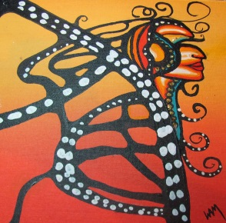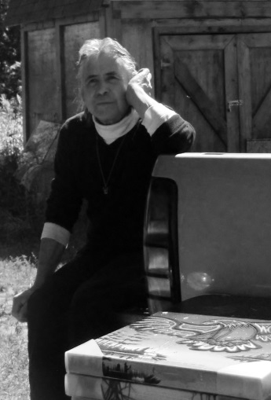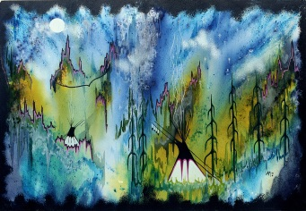

539 Yonge Street, Midland ON, L4R 2C6
www.williammonaguenativeart.com
(705) 527-4414

Meanings of Native Artwork
SUNSET HONEYMOON The power of togetherness and marriage.
BLUE MOON Remembering a loved one who has left this world. Inspired by love.
SKY WOMAN In the creation story, her father was the ruler of the Sky World. She was the first woman who gave birth to the first man.
TURTLE ISLAND "Turtle Island" is the english translation of the name given by the anishinabe to the american continent we stand on.
WALKING IN BALANCE WITH MOTHER EARTH The four seasons, four colors of man and four directions of the earth.
TOGETHER Two, In Love.
TURTLE SPIRIT Respecting the knowledge and vision of our educators.
MYSTICAL VILLAGE "Mystical Village" nominated for a Canada Arts Council award in 1994. A unique method of crystallizing acrylic paints to create northern lights effect.
ELDER PINES Signifying strength, knowledge and wisdom of our Elders. Inspired by Mother Earth and the Spirit World.
TRANQUILITY The painting commenced August 2001 as a depiction of two magnificent Georgian Pines in a scenic setting. The painting emerged into the artist’s creation of the healing that would take place after the tragedy surrounding the twin towers in New York on September 11, 2001. The forget-me-nots remind us not to forget what happened that tragic day. The painted turtles embody the symbol of healing and the reconstruction of Mother Earth. The Eagle represents the Ojibwa belief of the messenger answering our prayers; giving us the gift of strength and protection.
AWASIS The name of his youngest daughter. "Wapikehewasis"meaning"White Eagle Child".
WEST WIND Shoreline of Beausoleil Island on Georgian Bay – Parks Canada-
TEACHINGS Elders passing on knowledge to the young ones.Our future generation.
STRENGTH, HOPE & NEW BEGINNINGS Finding the strength and courage to begin a new way of life.
MIGRATION-LIFE ON BEAUSOLIEL Leaving Coldwater and their agricultural way of life. The Ojibwa were forced to live on Beausoleil Island for a short time.
NORTHERN LIGHTS – STORYTELLING It was said the northern lights were the glow of torches used to illuminate the path of soul spirits on their way to the land of peace.
EAGLES IN THE SKY Strength and Protection.
RAINBOW The creator placed a rainbow in the sky after the great flood. The rainbow in many cultures is a sign of inclusiveness, hope, pride and diversity.
THE STORY OF FAIRY LAKE The story of "Lady of the Blueberry Moon" on Beausoleil Island and the great protector "Nanaboozhoo" who heard her cries for help. A long furious battle was fought with a dreadful beast from another world; all were mortally wounded. The spirit of the woman forms the outline of Beausoleil Island. Nanaboozhoo’s body lay to rest on a small island near Giant’s Tomb. Rock stained blood on Fairy Lake forms the eye of the beast. Today, the spirit of this beautiful young woman can sometimes be heard singing or seen as she walks about her beloved island.
MEDICINE TENT Symbolizes healing through Native Traditional Medicine.

BLUE HERON The heron is a very good omen a symbol of wisdom, working with the elements of Mother Nature.
WOLF SPIRIT Resourceful and patient.
SUNSET EAGLE The Eagle represents the Ojibwa belief of the messenger answering our prayers; giving us the gift of strength and protection.
SPIRIT LOON Symbolizes peace, tranquility, and generosity.

www.williammonaguenativeart.com 705-527-4414

